[enrich salon](http://www.enrichsalon.com/index.php)

[Academy +](javascript:void(0))

* [COURSES](http://www.enrichsalon.com/courses.php)
* [Trainers](http://www.enrichsalon.com/trainers.php)
* [About us](http://www.enrichsalon.com/about-us.php)
* [Gallery](http://www.enrichsalon.com/gallery.php)
* [careers](http://www.enrichsalon.com/careers.php)
* [Write to us](http://www.enrichsalon.com/write-to-us.php)

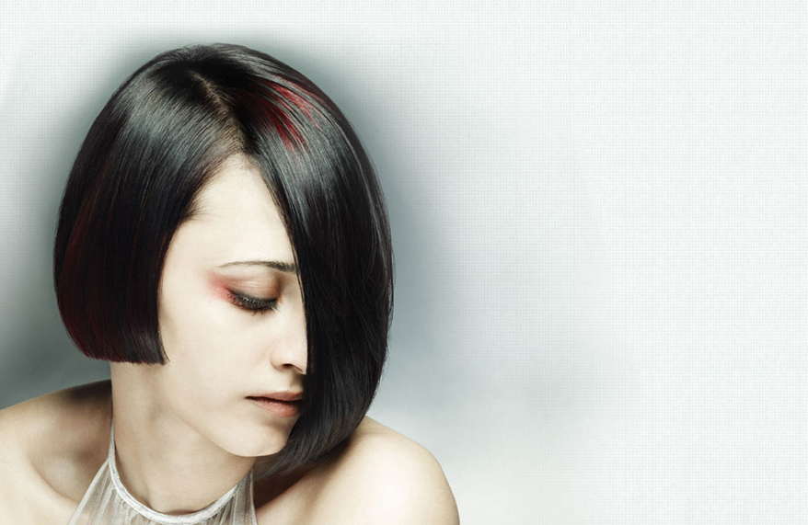

**Appointment**

Enrich started in 1997, with Mulund as its first location. As we evolved and brought a whole spectrum of professional hair and skin care services under one roof, we are now a one stop destination for grooming and personal care. This made us a commercial success story with many brands trying to emulate us. The Enrich Loyalty Program has achieved epic proportions with a loyal clientele of more than 1,00,000 and still counting.

**The Brand Today**

Enrich is the largest unisex salon chain in Mumbai. It has achieved "Superbrand" status. Its mantra of offering world class services and products at accessible locations with affordable pricing has made it an industry leader. Enrich is constantly expanding. We offer professional hair and skin services and products standardized to meet stringent quality control.

**The Team**

Enrich has been a pioneer in nurturing talent. The team is young, with a drive and passion to be the biggest and the best. The team is constantly trained and inspired. It is the only company whose creative heads present trends for the season. This has now become a style statement in the fashion world. With Enrich constantly investing in education of its team, whether technical training in hair and skin or soft skills like communication or customer service excellence programs, we believe that education is the key for a rewarding and successful career. With a core team that is highly experienced, internationally exposed and won serveral accolades, Enrich is the numero one employer choice for hairdressers, beauty therapists and managers. The staff strength of 400 technicians is unrivalled and amongst the most dedicated to support the Enrich Philosophy..

Top of Form



|  |  |  |
| --- | --- | --- |
| Appointment | | |
| Your Name | : |  |
| Your E-Mail Address | : |  |
| Already Enrich Member | : | Yes No |
| Salon Interested | : |  |
| Services Interested | : | |  |  | | --- | --- | |  | Bridal Packages | |  | Hair | |  | Hands & Feet | |  | Make Up | |  | Skin | |
| Appointment Date | : | - 12 - |
| Your Address | : |  |
| Your Message | : |  |
|  |  |  |
| **Appointment request will be confirmed via email or phone call. If you do not receive a confirmation notification, your appointment has not been booked.** | | |
|  | | |

Bottom of Form

[facebook](http://www.facebook.com/enrichsalonandacademy)[twitter](http://twitter.com/enrichsalon)[blog](http://enrichsalonandacademy.blogspot.com/)

* [Hair](http://www.enrichsalon.com/index.php)
* [Skin](http://www.enrichsalon.com/skin.php)
* [Hands & feet](http://www.enrichsalon.com/hands-feet.php)
* [Make up](http://www.enrichsalon.com/make-up.php)
* [Bridal Packages](http://www.enrichsalon.com/bridal-packages.php)
* [Appointment](http://www.enrichsalon.com/appointment.php)
* [Offers](http://www.enrichsalon.com/offers.php)
* [Salon Locations](http://www.enrichsalon.com/salon-locations.php)
* [Membership](http://www.enrichsalon.com/membership.php)
* [Press](http://www.enrichsalon.com/press.php)
* [Powered By Aurum](http://www.aurumcommunications.com/)
* ©2011 Enrich